**Centered and Averaged Fuzzy Entropy to Improve**

**Fuzzy Entropy Precision**

P=1000 ??

r=std(data)/10 ????

m = 2 ????

type = ‘T’/’R’/’I’/’G’ ???

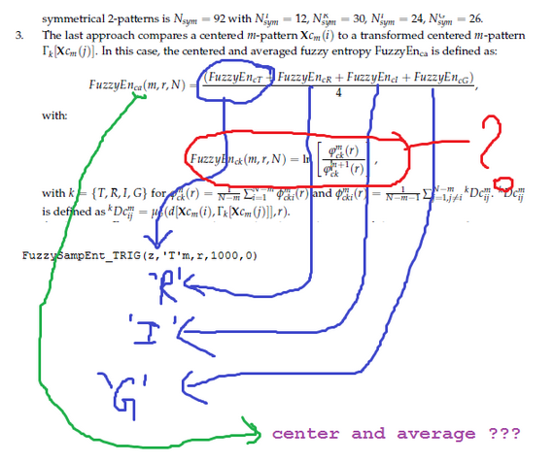

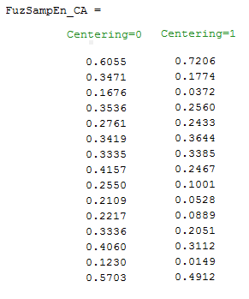

[1] Deepak is unsure about whether to use ‘r’ or ‘r x Standard Deviation’ as a parameter (e.g. 0.1 or 0.2, or 0.1 * SD or 0.2 * SD). Please can you clarify.

r has to be multiplied by the standard deviation of the time series.

[2] Should the same default value of ‘r’ be used for all four operations (T, R, I, G)? If so, would you suggest 0.1, 0.2 or another value?

The same r value should be chosen for T, R, I and G.

[3] Should the average of all four results (as in the equation at the bottom of p 4 in your published paper) be reported, and/or values for the individual T, R, I, G methods?

Only the average value is necessary.

[4] In other words, should users have the option to select T, R, I, G or ALL?

You can allow T, R, I, and G, but the final computation uses the four values.

IN CEPS

T,R,I,G,FC(avg)

[5] What default value would you suggest for m? (2 or …)

Yes, you can suggest 2 as a default value.

[6] Should we (or other CEPS users) use FEca consistently, rather than FEa or FEc?

You can propose the 3 options.

- CEPS …. Anaysiss suggestion …

[…. ]

[7.1] Is this method suited to continuous data, or would that require some form of discretisation/quantisation/normalisation first?

I am not sure to understand your question here. As the processing is performed on time series, it is a discrete signal. No normalization is necessary.

[7.2] Is there an optimal data length for CAFE? (I am thinking about short, medium and long datasets - 2-minute RR interval data vs 2-minute EEG recorded at 500 Hz, or even 24-hour RRi data, for example)

For most of the entropy methods, the longer the signal, the better it is.

[7.2] Is the method affected by noise, filtering, sample rate/down-sampling?

We have not tested this yet.

- CEPS analysis …

[7.3] Is the method suited to both stationary/nonstationary and linear/nonlinear data?

For sample entropy (but this should be rather similar for fuzzy entropy), you can read an interesting discussion on this point in Costa et al., 2005 (page 10 and in Appendices).

[8] MSampEn (or MFE) and RSampEn (or RFE) are median and IQR values – should these be reported by users of this method?

I am not sure to clearly understand your question but I think the entropy value is the most important value for users.